OBSERVATION AND REPORTING

I .Observe the following pictures and answer the questions.

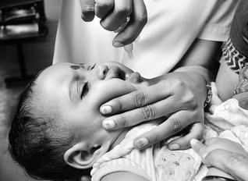1.Name the programme established by the Government of India in 1994 to eradicate polio.

________________________

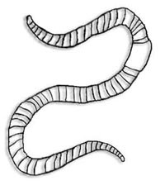 2. ________________ is called farmer’s friend.

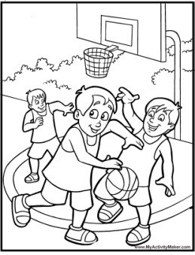

3.Name the game. _____________________________

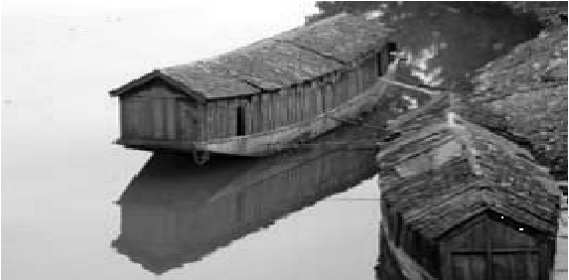

4. Name the lake of Sri Nagar where GauravJani stayed in house boat.

___________________________

5. How many players in this game ? 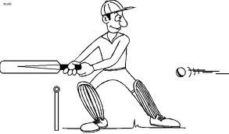

______________________

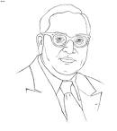

6. _______________________was the head of the committee who framed our constitution.

7. Pulse polio programme is to eradicate this disease .

a) Cancer (b) B.P (c) Polio (d) Blindness

8. The other name for forest in Kuduk language is

(a) Dance (b) snake (c) Song ( d) Torang.

9. Babies who are born together and look exactly alike are known as

a) Twins ( b) Identical twins (c) Joined twins (d) copies

10. We play this instrument by blowing air

(a) Bongo (b) Tabla (c) Guitar (d) Mouthorgan

II. Answer the following questions:

1. What happened on 26 january, 2001 ?

________________________________________________________________________________________________________________________________________________________________________________________________________________________________________________________________________________________________________

2. What is the use of stethoscope? Draw its diagram.

______________________________________________

______________________________________________

______________________________________________

______________________________________________

3. Where do the caravan of families on the move settle ?

______________________________________________________________________________________________________________________________________________________________________________________________________________________________

4. Name four sports that are played as a team .

____________________________________________________________________________________________________________________________________________________

5. Why do people do different kinds of jobs ?

______________________________________________________________________________________________________________________________________________________________________________________________________________________________

IDENTIFICATION AND CLASSIFICATION

1. _________ ___________is the highest dam in India.

(a) Tehri Dam (b) Farakka dam (c) Hirakud dam (d) Bhakhra Nangal dam

2._____________________ is the respiratory gas.

(a) Nitrogen (b) Oxygen (c) Hydrogen (d) Ozone

3. _____________________ advocated the principle of dignity of work.

(a) Gandhiji (b) Subash Chandra Bose (c) Jawaharlal Nehru (d) Jenner

4._____________________ farming known as slash and burn cultivation.

(a) Step farming (b) Horticulture (c) Jhoom (d) none of these

5.Choose the correct statement.

1. Petroleum forms naturally and slowly.
2. Petroleum forms artificially and slowly.
3. Petroleum forms naturally and quickly.
4. Petroleum forms artificially and quickly.

1. Describe the houses of Leh ?

________________________________________________________________________________________________________________________________________________________________________________________________________________________________________________________________________________________________

2. write the full forms:

1. L.P.G. ______________________________

2. C.N.G. _____________________________

3. Write the names of four natural disasters .

______________________________________________________________________________________________________________________________________________________________________________________________________________________________

4. Complete the following table

|  |  |
| --- | --- |
| Your special habit or trait | To whom does it similar to? |
| 1. |  |
| 2. |  |

5.How is life in the village different from that of cities ?

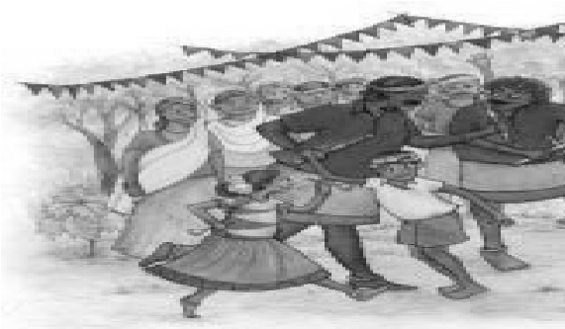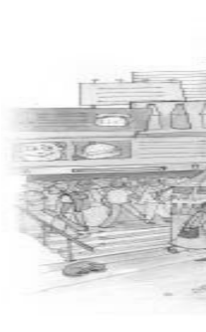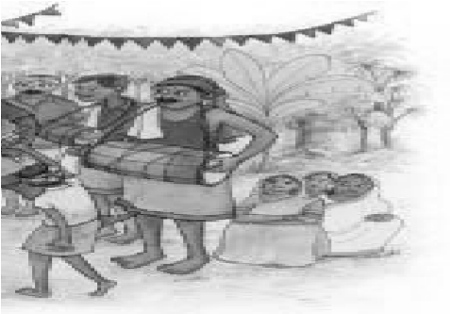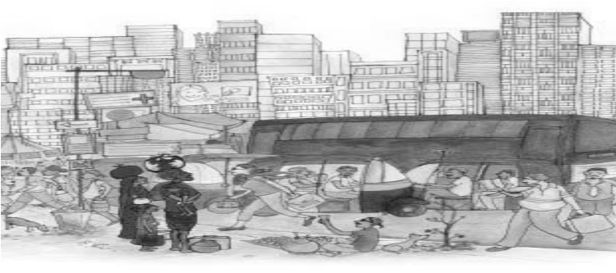

_________________________________________________________________________

_________________________________________________________________________

__________________________________________________________________________

Mark the following in the map of India .

1. 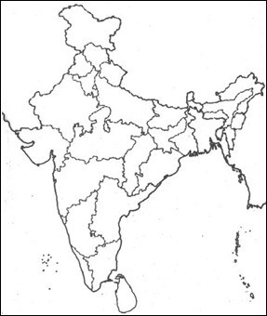Uttrakhand
2. Gujarat
3. Mizoram
4. Jharkhand
5. Bay of Bengal

DISCOVERY OF FACTS

1. Intensity of earthquake is measured in ___________________ scale.

2. National game of India _____________________.

3. Forest dwellers are called _________________.

4. Who is ‘Mukadam’?

__________________________________________________________________________

__________________________________________________________________________

6. What do you mean by “pulse polio”?

__________________________________________________________________________

__________________________________________________________________________

_________________________________________________________________________

7. Give short notes on

1. Right to forest act 2007 _______________________________________________________________________

______________________________________________________________________________________________________________________________________________________________________________________________________________________________

1. Identical twins

_________________________________________________________________________________________________________________________________________________________ _______________________________________________

8. Why is earthworm called a farmer’s friend ?

________________________________________________________________________________________________________________________________________________________________________________________________________________________________________________________________________________________________________________________________________________________________________________________________

9. What kind of problems do people face who are displaced or asked to move from their place ?

___________________________________________________________________________________________________________________________________________________________________________________________________________________________________________________________________________________________________________________

10. Draw the picture of your school